Exp. No: 4 Analysis of Continuous Charge Distribution in electric field. To find the (i) line charge density, (ii) Surface charge density and (iii) Volume charge density for any specific (a) line, (b) surface or (c) volume.
Date:
Aim: To write program for continuous Charge Distribution in electric field. The different types of charge density there are (a) Linear Charge Density, (b) Surface Charge Density,
(c) Volume Charge Density using SCILAB.

Software required:
- SCILAB version 6.0.1
Theory: Program:
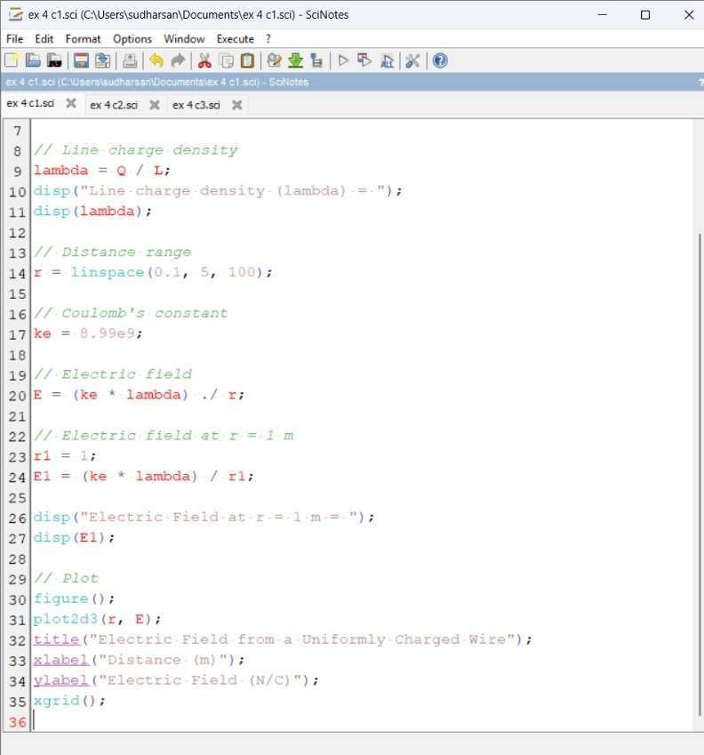

Output:

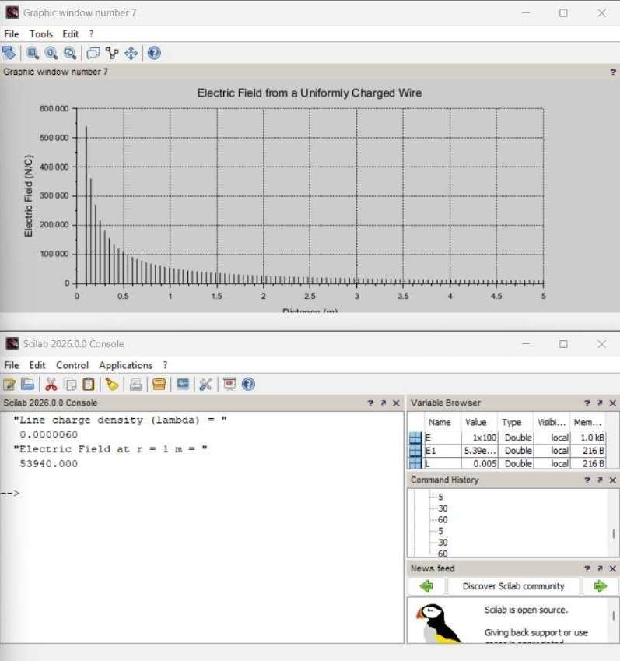

Calculation:
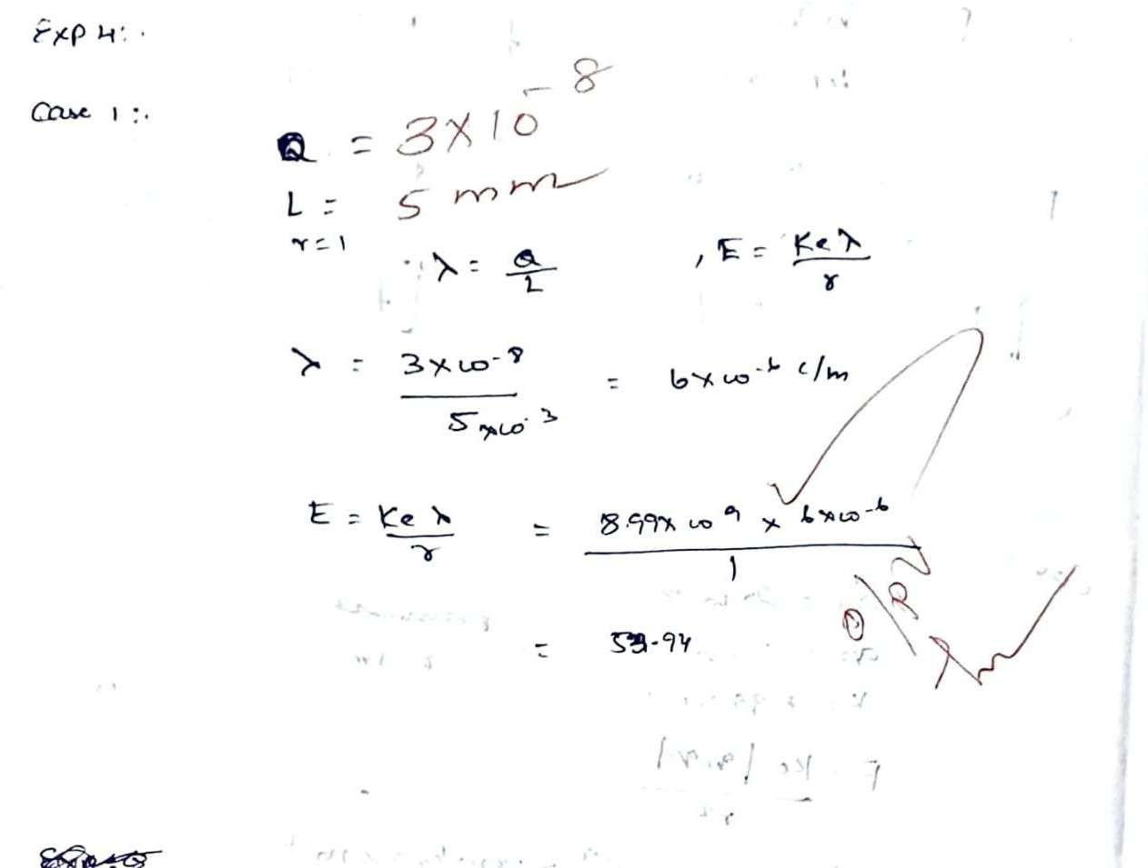

Case 2:
A long wire of length L=10m carries a uniform charge of Ǫ=50μC. The goal is to calculate the line charge density λ and determine how the electric field behaves as a function of distance from the wire.
Program:

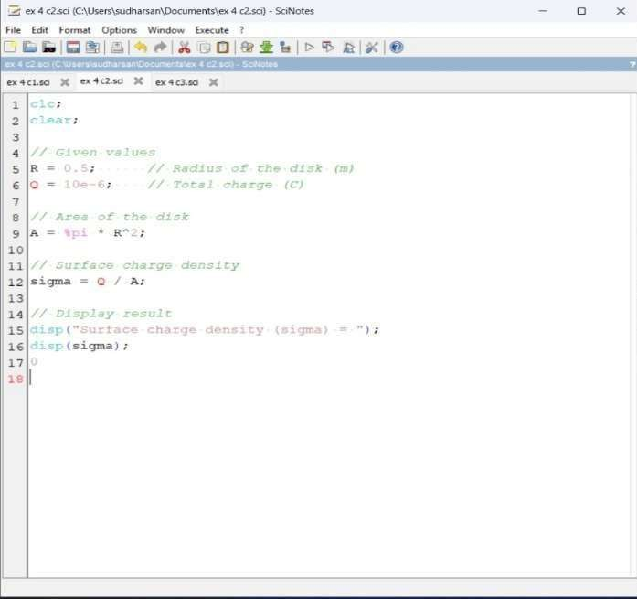

Output:

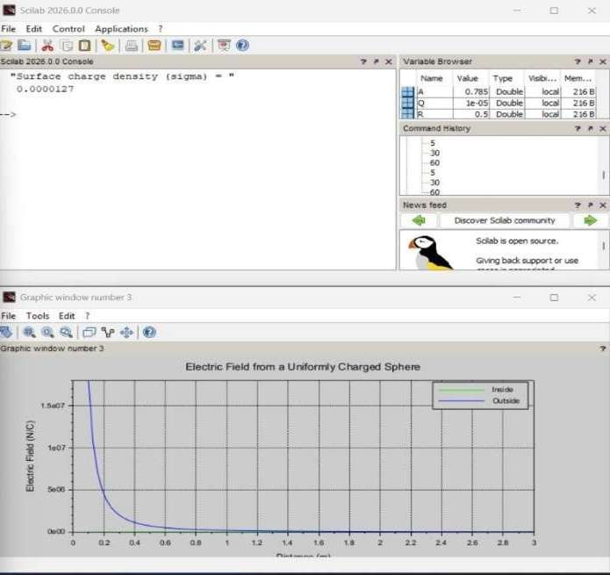

Calcution:
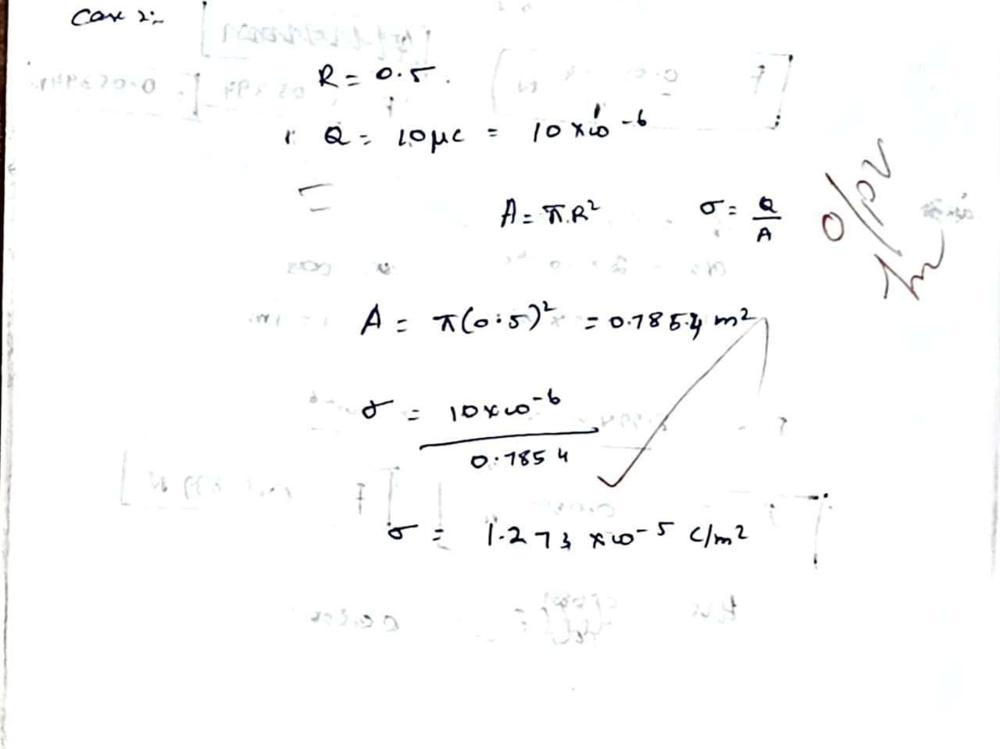
Case 3:

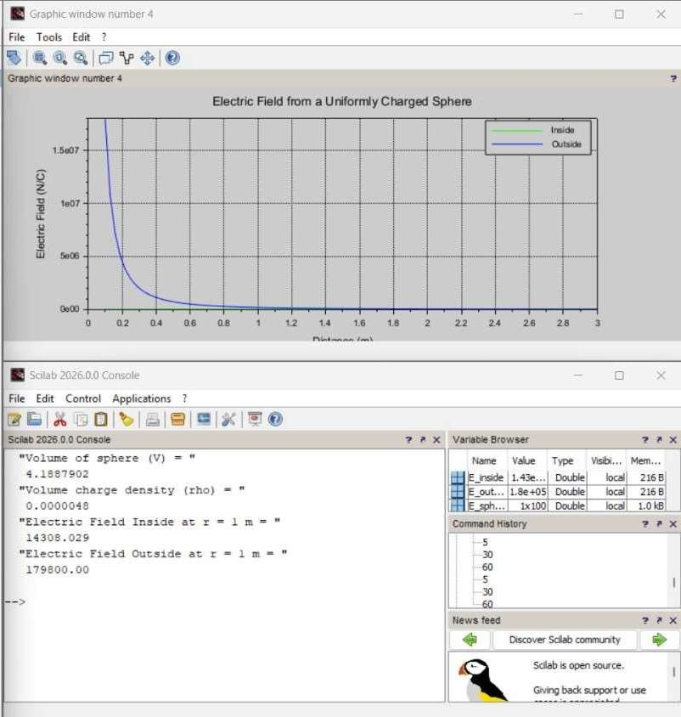
Given a uniformly charged disk of radius R=0.5m with total charge Ǫ=10μC, calculate the surface charge density and plot the electric field along the axis of the disk. Explain the behavior of the electric field as a function of distance from the center of the disk.
Program:
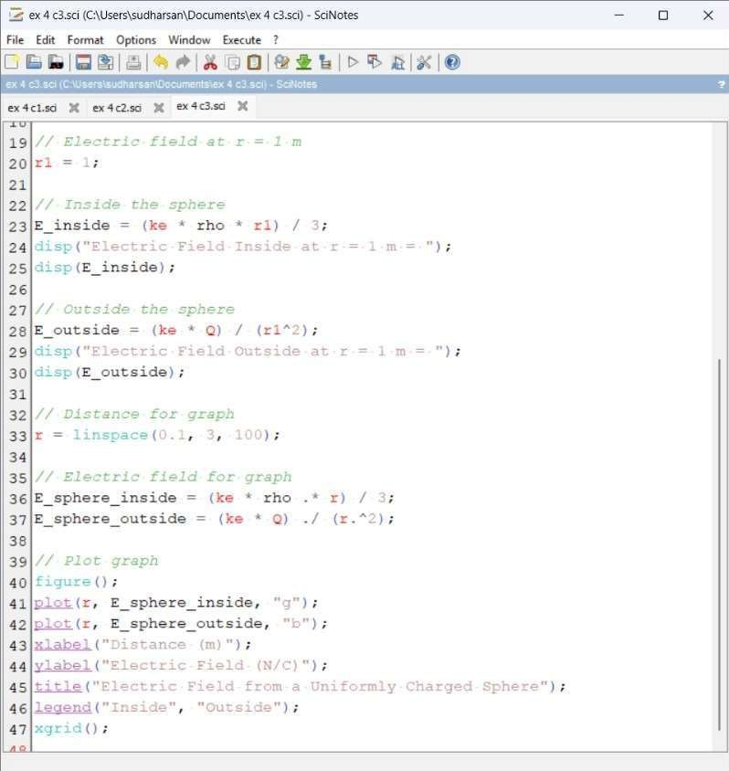
Output:

Calcution:

